ECOR 1010 - DAY 4

Pop quiz
(A km/m^3) ^-1 = 8.83L/100km
a) m
b) ft^3/L
c) mi/gal
d) m^3/L
Measurements, Units, and Errors
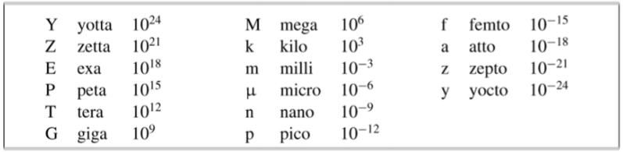
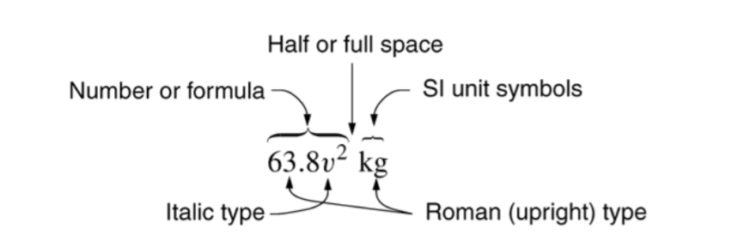Unit symbols are not modified with subscripts:
– Vmax = 200 V not V = 200 Vmax.
– 87.2 g ± 0.4 g or (87.2 ± 0.4) g; but not 87.2 ± 0.4 g
Engineering Notation:
- Exponent of 10 is a multiple of 3 (e.g. 30.14x10³)
Measurements
Explicit Uncertainty Notation:
Uncertainty may be given in either absolute or relative form.
– Fixed notation with error in absolute form
• vs = 343.5 m/s ± 0.9 m/s = (343.5 ± 0.9) m/s
– Fixed notation with error in relative form
• vs = 343.5(1 ± 0.26%) m/s.
Implicit Uncertainty Notation:
If quantity is written without explicit uncertainty, uncertainty is taken to be +5 in digit immediately to the right of the least significant digit.
Uncertainties
For addition or subtractions, we add absolute uncertainties
For multiplication or division, we add relative uncertainties.

